What are CSS Selectors? CSS selectors are patterns used to target and style HTML elements. They define which HTML elements the CSS rules apply to, based on the element type, class, ID, attributes, or state.

Example HTML Document Using Different CSS Selectors
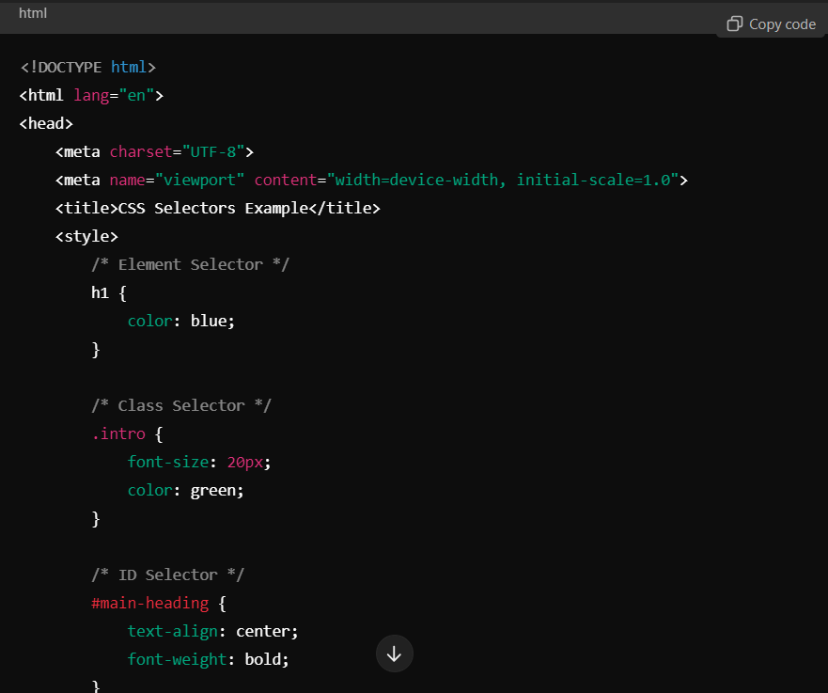

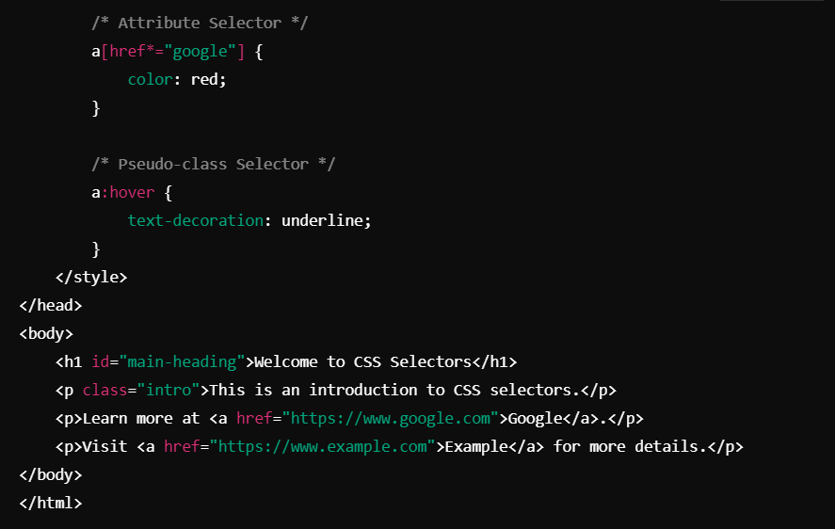

Explanation of Selectors:
- Element Selector (h1):
Targets all <h1> elements. In the example, it sets the heading color to blue.
- Class Selector (.intro):
Targets elements with the intro class. In the example, the class is applied to a paragraph, which makes the text green and increases the font size.
- ID Selector (#main-heading):
Targets the element with the unique id="main-heading". It centers and bolds the heading text.
- Attribute Selector (a[href*="google"]):
Targets links (<a>) that contain the word "google" in their href attribute. The text color of these links is changed to red.
- Pseudo-class Selector (a:hover):
Applies styles when the user hovers over a link (<a>). In the example, hovering over any link adds an underline.

